
A Project Report
On
Electronic Voting Machine
Submitted by :-
PRACHI AGRAWAL, ROLL NO. - 2215001245
SOMYA RAWAT, ROLL NO. - 2215001758
SUHANI GOYAL, ROLL NO. - 2215001791
SARTHAK GUPTA, ROLL NO. - 2215001590
TARUN KUMAR SOROUT, ROLL NO. - 2215001849
Supervisor
Mr. Sachin Sharma
ASSISTANT PROFESSOR

Department of Computer Engineering and
Applications
G.L.A. University Mathura (U.P.)


GLA University, Mathura - 281406
Date of Submission-15/05/2023

DECLARATION

We PRACHI AGRAWAL, B.Tech CS 1st year , Roll No-2215001245 ; SOMYA RAWAT, B.Tech CS 1st year , Roll No-2215001758 ; SUHANI GOYAL, B.Tech CS 1st year , Roll No-2215001791; SARTHAK GUPTA, B.Tech CS 1st year , Roll No-2215001590; TARUN KUMAR SOROUT, B.Tech CS 1st year , Roll No-2215001849 hereby declare that the work presented in this project report entitled ‘Electronic Voting Machine’ is an authentic record of our own work carried out under supervision of SACHIN SHARMA(ASSITENT PROFESSOR).

Prachi Agrawal, Roll No.-2215001245, Signature of Student -
Somya Rawat, Roll No.-2215001791, Signature of Student -
Suhani Goyal, Roll No.-2215001590, Signature of Student -
Sarthak Gupta, Roll No.-2215001590, Signature of Student -
Tarun Kumar Sorout, Roll No.-2215001849, Signature of Student -

CERTIFICATE
This is to certify that the above statement made by the students are correct to the best of my knowledge and belief.
Date:15/05/2023
Place: Mathura

Name and Signature with Affiliation of Supervisor

Contents
Certificate & Declaration |  | 1
Table of Contents |  | 2
- Introduction, Motivation, Objective  - Objective |  | 3
2.Project Description and Work done |  | 5
- Geotagged Images of Students  - WWORKplace of work |  | 11
4.Findings and Conclusion |  | 12
5.Bibliography/ References |  | 13

Chapter - 1
Introduction, Motivation and Objective
INTRODUCTION
Electronic voting machine (EVM) is an electronic device used to record vote in place of ballot paper and boxes which were used earlier in conventional voting system. EVM retains all the characteristics of voting by ballot paper, while making polling a lot more expedient. Being fast and absolutely reliable, the EVM saves considerable time, money and manpower. And helps maintain total voting secrecy without the use of ballot papers. And, at the end of the polling, just press a button and there you have the result.
MOTIVATION
Electronic voting intends to speed the counting of ballots, reduce the cost of paying to count manually and can provide improved accessibility for disabled voters. Also in the long term, expenses are expected to decrease. Result can be reported and published faster. Voters save time and cost by being able to vote independently from their location. This may increase overall voter turnout. The citizen groups benefiting most from electronic elections are the ones living abroad, citizens living in rural areas far away from polling stations and the disabled with mobility impairments.

OBJECTIVE
To make an Electronic Voting Machine for the selection of Class Representative. And we can use this for the selection of mess in-charge etc.
The election will conduct under the supervision of observer.
The objective is to remove these major problems in the present system :-
- More human effort required.
- Time consuming.
- Difficult to organize.
- Lack of participation.
- Problem of Inconsistency.

CHAPTER -2
DESCRIPTION AND WORKDONE
WORK DONE
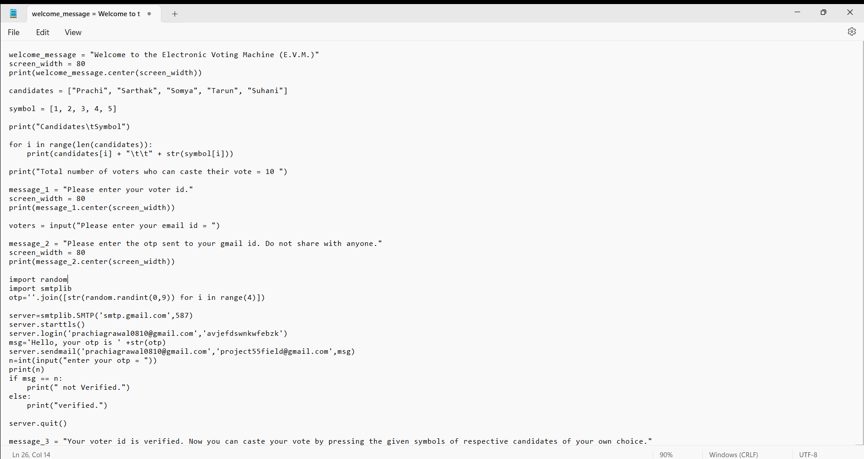
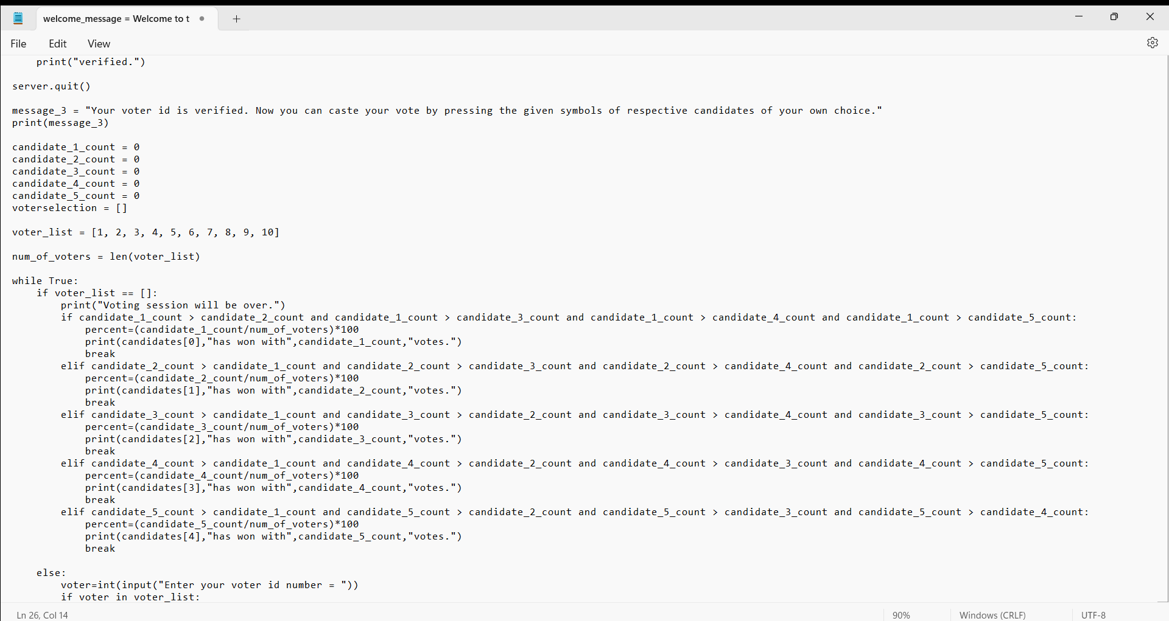

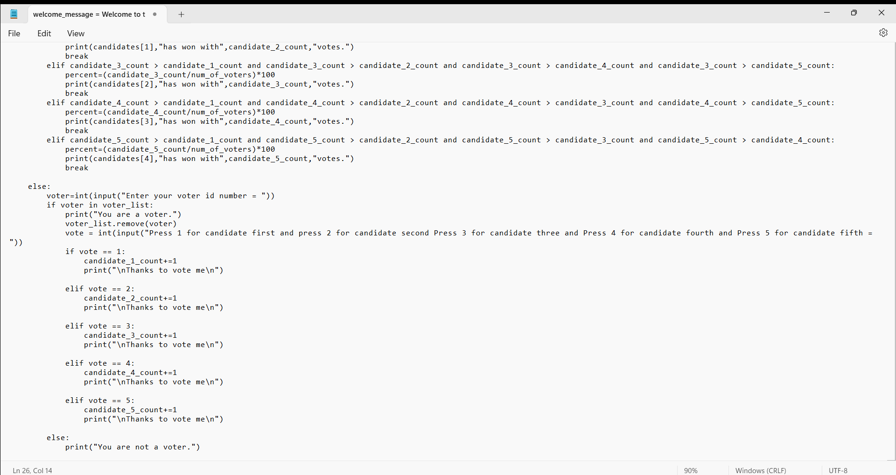

OUTPUT
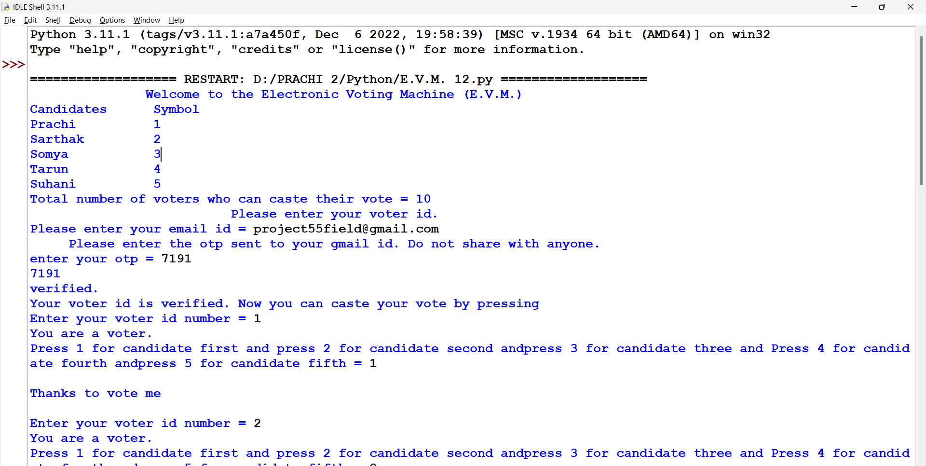
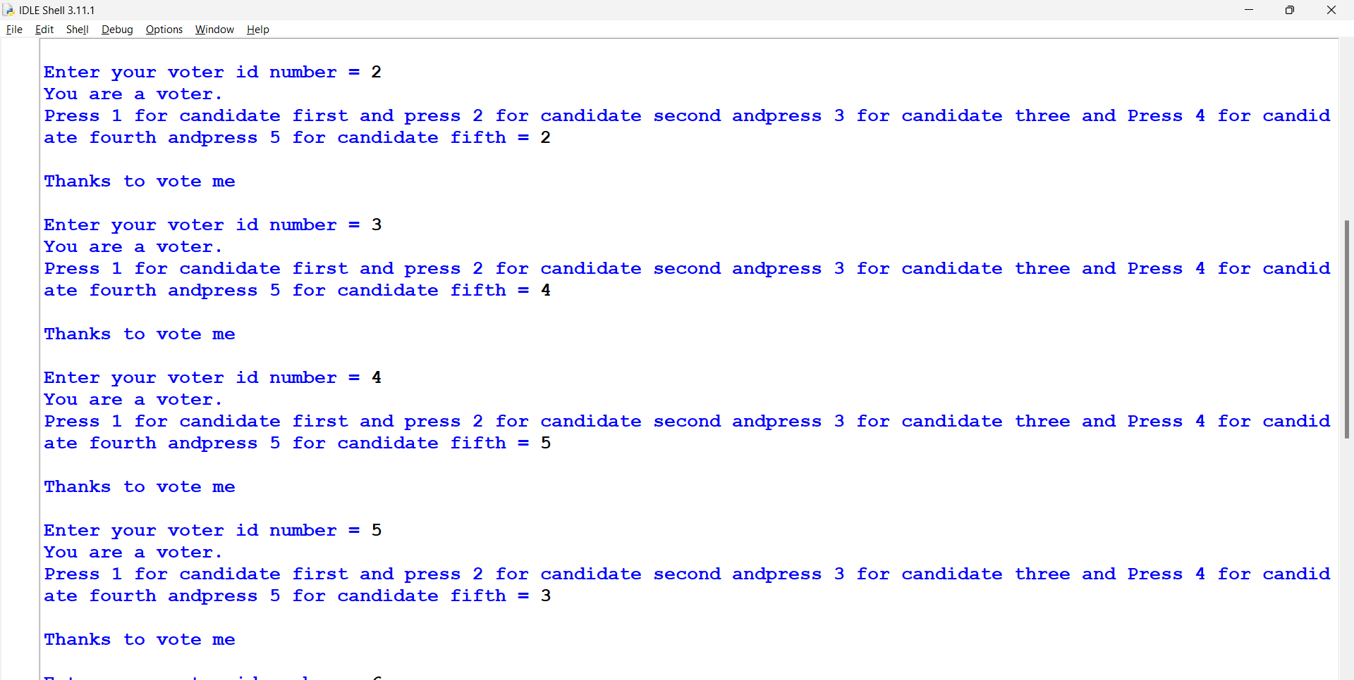

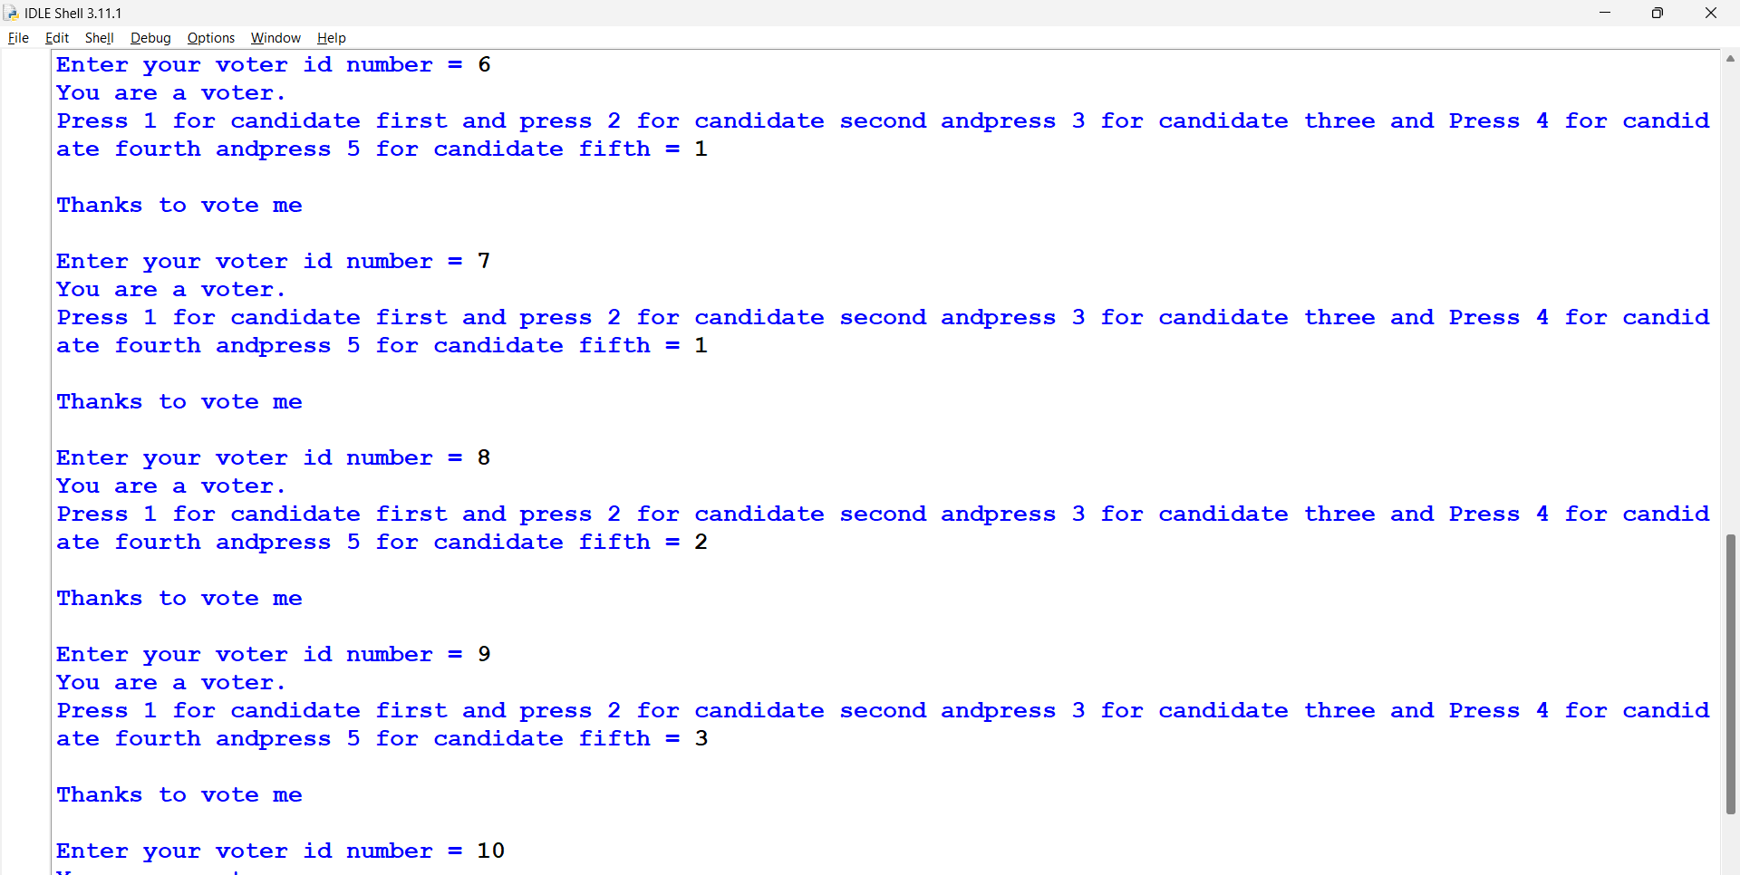
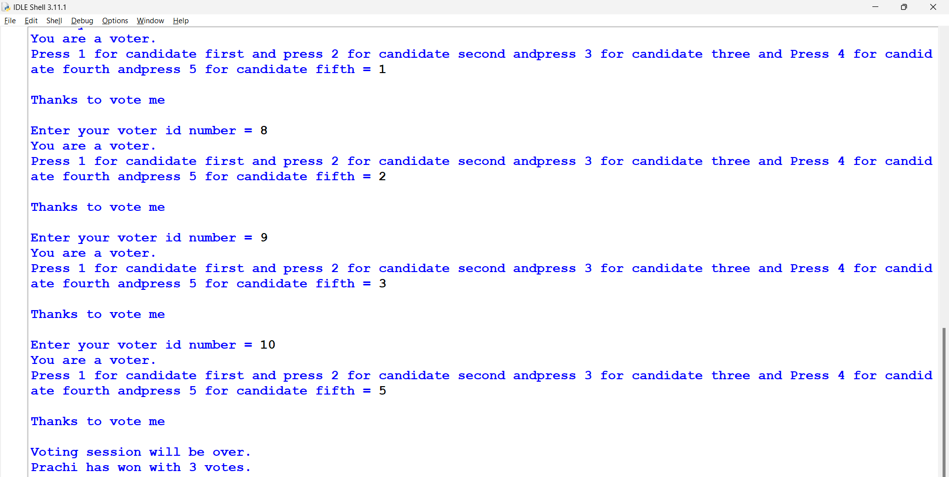

DESCRIPTION

TThis project is divided into main 3 modules:

- Login- In this module, voter have to mention their details like e-mail.
- OTP - In this module, voter have to enter the OTP generated on their mail.
- Section of candidate - In this module voter have to vote for their favourite candidate.
- Result - In this module the voter can see the result of election.

Chapter - 3
Geotagged Images of Students at the place of work
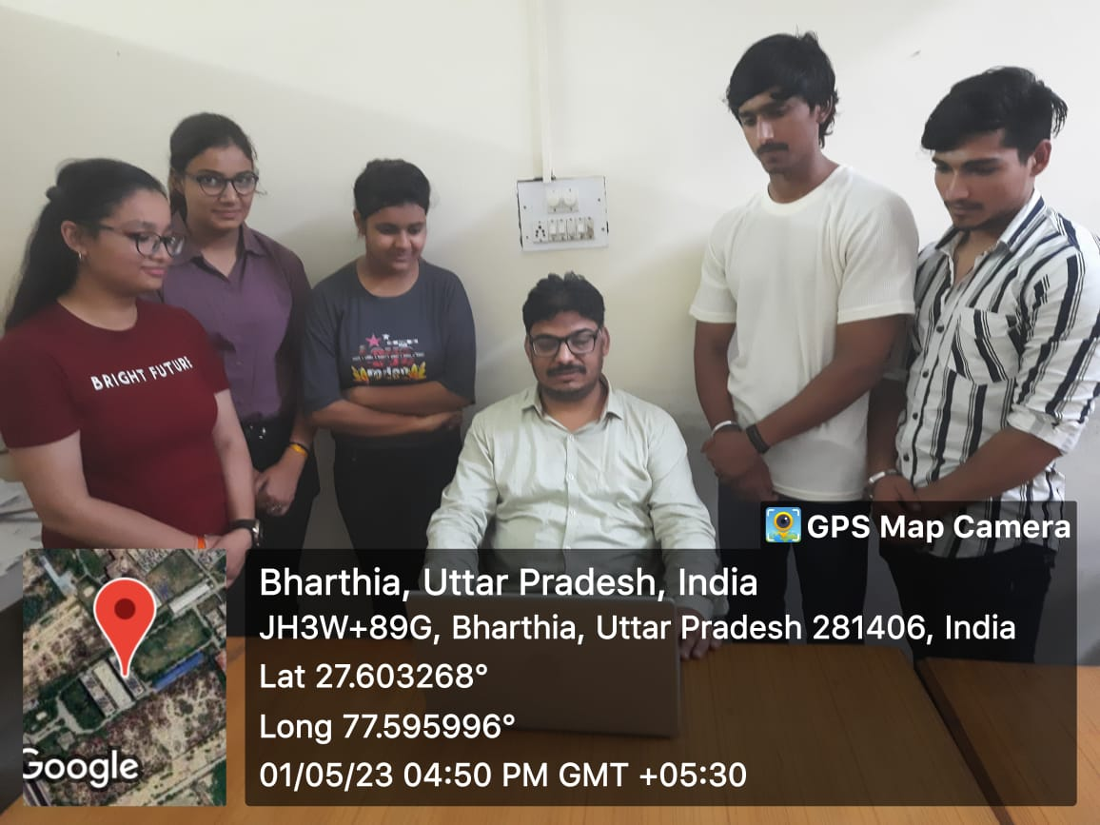  Geotagged Image 1 | 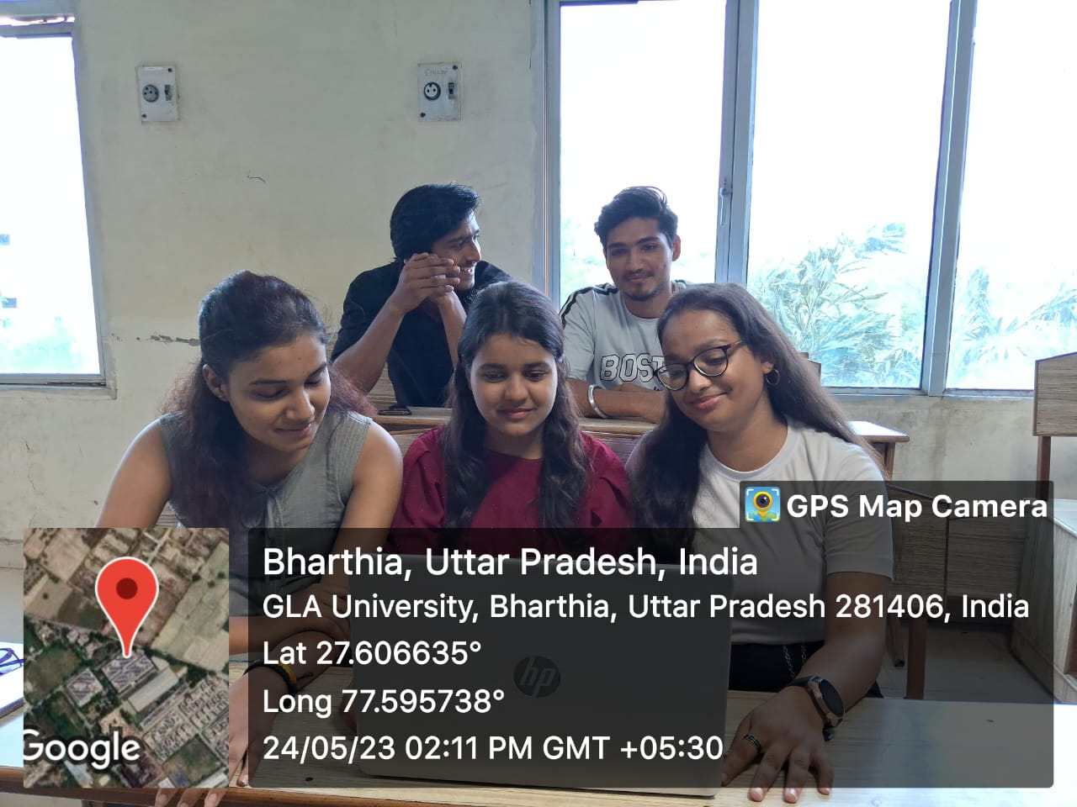  Geotagged Image 2
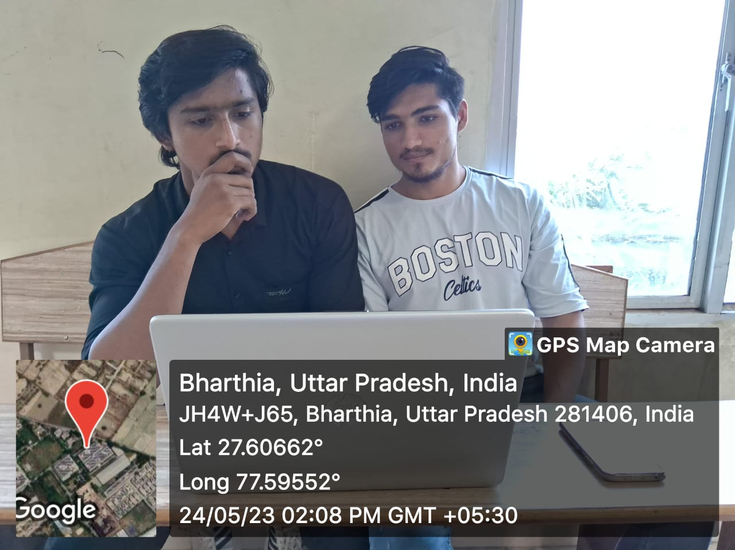  Geotagged Image 3 | 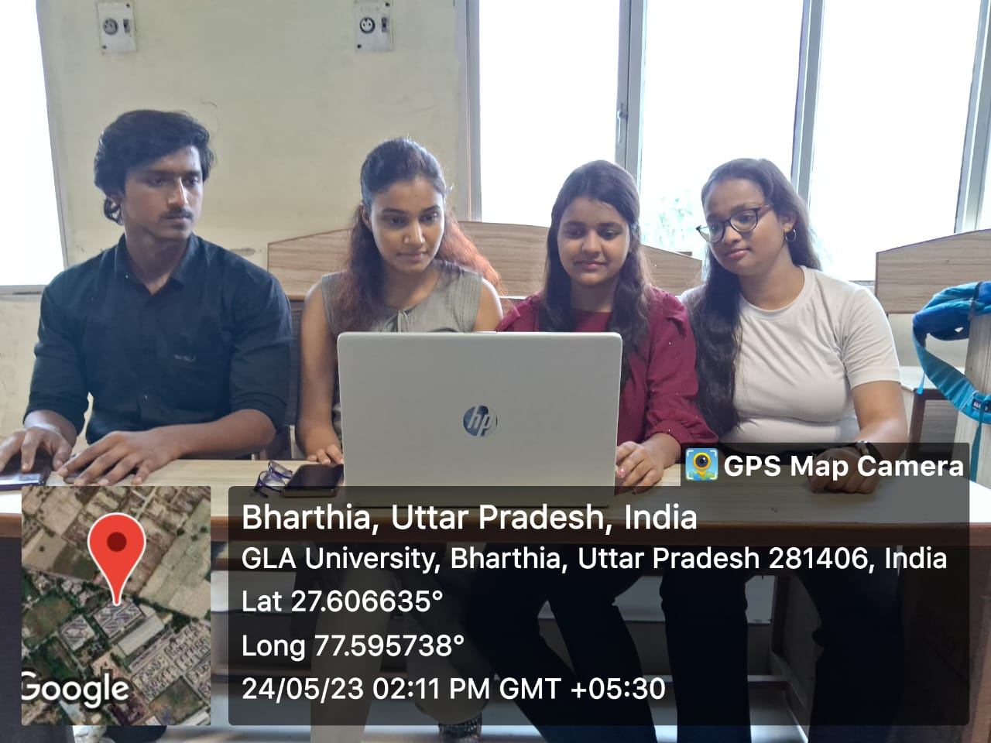  Geotagged Image 4

Chapter – 4

Findings and Conclusions

Through this application we are introducing few functionalities for Admin such as result management in which Admin will upload the result and he/she can edit and delete the result. And also, he/she will handle the voter and leader accounts.
Firstly, the voter has to enter their details mentioned on the screen, then an OTP is generated on the mail ID enter by the voter. In the second step the voter has to enter the OTP. Then he\she can vote for the leader he\she want.

Bibliography/ References

https://www.google.com/
https://github.com/
https://www.geeksforgeeks.org/
https://openai.com/blog/chatgpt/
https://www.youtube.com/

THANK
YOU

